Work life balance in the practice of law

Date: October 17, 2023
Time: NOON TO 1 P.M. CST
https://us02web.zoom.us/j/

1 Hour Free Ethics CLE

presented by:

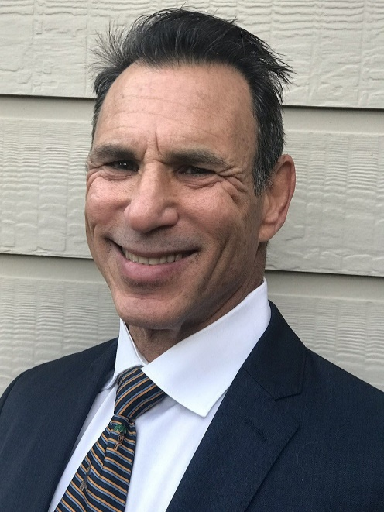

paul S jacobs, jd

TLAP Professional

Austin, texas

Dallas/fort worth, Texas

